Convert Azure SQL data to PDF using flow

Steps to follow

1. Create an Instant flow as trigger
2. Add an Action Azure SQL Data warehouse 🡪 Get Rows

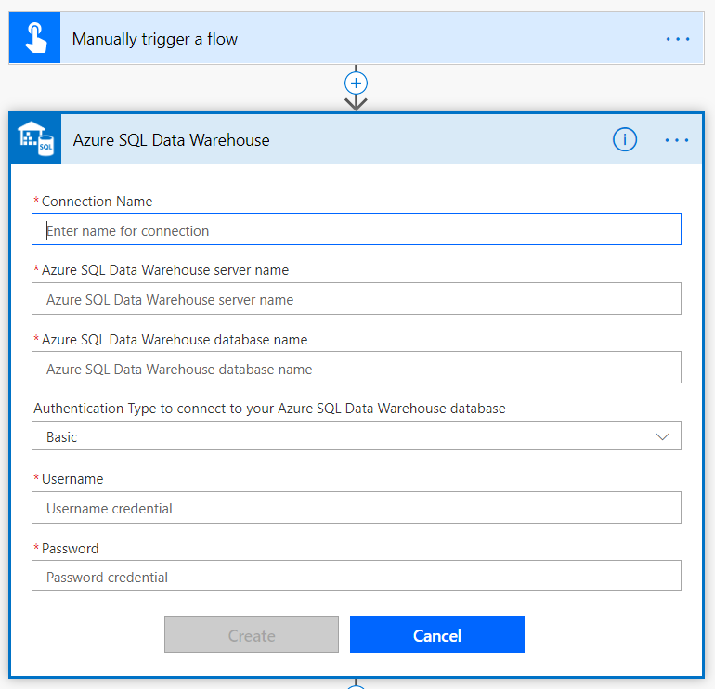

1. Fill required fields
   1. Connection Name
   2. Server Name
   3. Database Name#
   4. Authentication
   5. Username
   6. Password

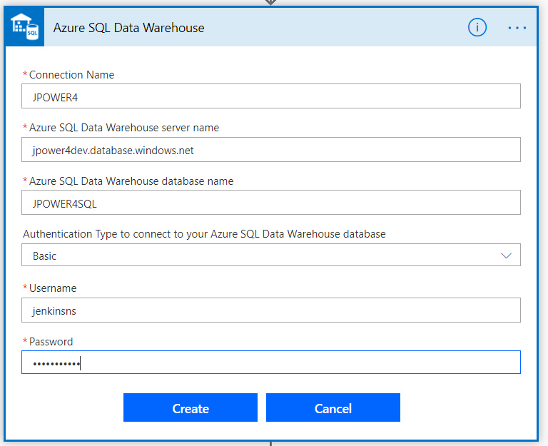

1. Select the table to get rows, select Product Table

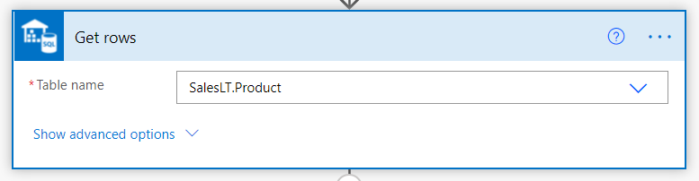

1. Add as action to convert the table rows to HTML table

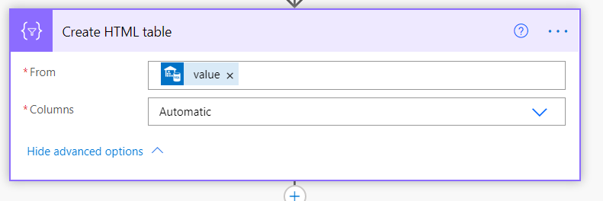

1. Form 🡪 Get Rows output

* Add Custom columns and map values from the output

1. Add another action the Muhimbi “**Convert HTML to PDF**” action to the Flow Canvas

* Create the account before using
* This is free for small Projects
* Set the HTML output as source

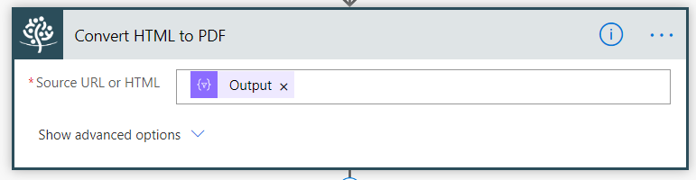

1. Add another action to send email
2. Give the attachment name
3. Select the attachment content as Processed file content

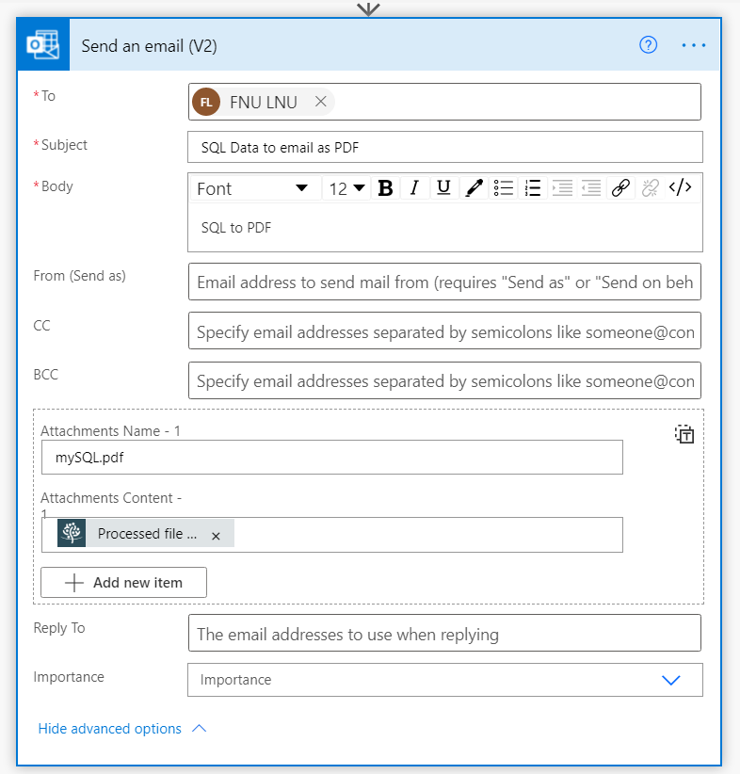

1. Save and test the flow

Output in Email

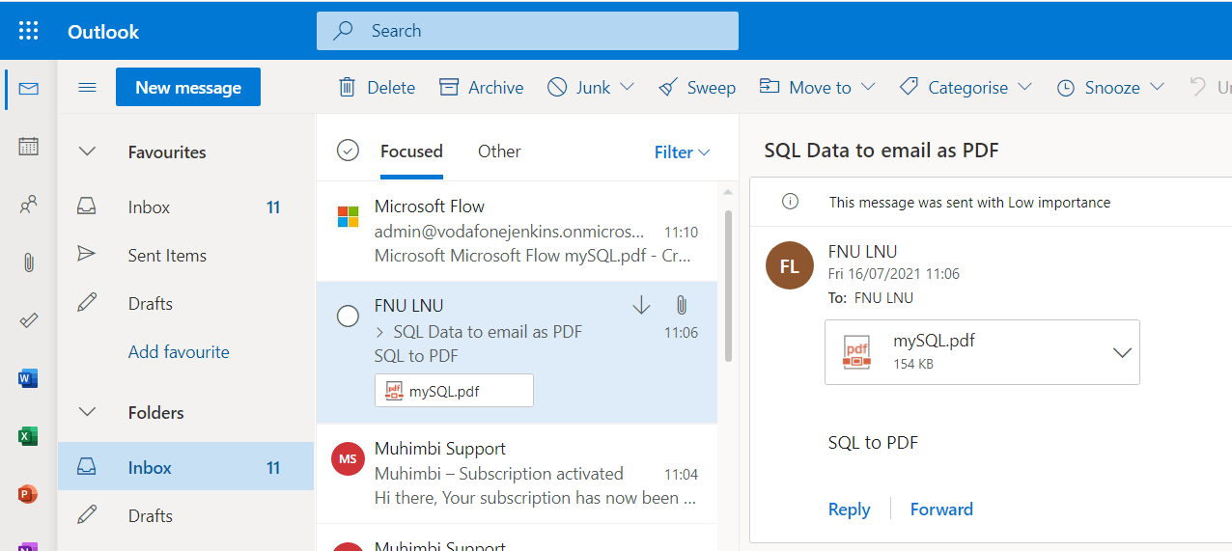

Example from SQL Sample DB

